Data Science Nanodegree:

Module 2:

## Lesson 1: The Data Science process:

CRISP-M: Cross industry standard process for Data Mining:

* Business Understanding
* Data Understanding
* Data preparation
* Modeling
* Evaluation
* Deployment

1. **Business Understanding** - this means understanding the problem and questions you are interested in tackling in the context of whatever domain you're working in. Examples include:

* How do we acquire new customers?
* Does a new treatment perform better than an existing treatment?
* How can improve communication?
* How can we improve travel?
* How can we better retain information?

#### Business Questions (Stack Overflow survey)

1. How do I break into the field?
2. What are the placement and salaries of those who attended a coding bootcamp?
3. How well can we predict an individual's salary? What aspects correlate well to salary?
4. How well can we predict an individual's job satisfaction? What aspects correlate well to job satisfaction?

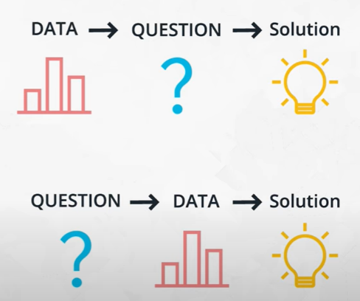

1. **Data Understanding** - at this step, you need to move the questions from **Business Understanding** to data. You might already have data that could be used to answer the questions, or you might have to collect data to get at your questions of interest. Some businesses try to collect data as much as possible then look insight of them to understand more.
2. **Data Preparation** - Luckily stack-overflow has already collected the data for us. However, we still need to wrangle the data in a way for us to answer our questions. The wrangling and cleaning process is said to take 80% of the time of the data analysis process. You will see that will hold true through this lesson, as a majority of the remaining parts of this lesson will be around basic data wrangling strategies.

#### CRISP-DM

In working with missing values, categorical variables, and building out your model, it was probably easy to lose sight of the big picture of the process. Let's take a quick second to recap that here, and pull together the results you should have arrived through your analysis.

1. Business Understanding

1. How do I break into the field?
2. What are the placement and salaries of those who attended a coding bootcamp?
3. How well can we predict an individual's salary? What aspects correlate well to salary?
4. How well can we predict an individual's job satisfaction? What aspects correlate well to job satisfaction?

2. Data Understanding

Here we used the stackoverflow data to attempt to answer our questions of interest. We did 1. and 2. in tandem in this case, using the data to help us arrive at our questions of interest. This is one of two methods that is common in practice. The second method that is common is to have certain questions you are interested in answering, and then having to collect data related to those questions.

3. Prepare Data

This is commonly denoted as 80% of the process. You saw this especially when attempting to build a model to predict salary, and there was still much more you could have done. From working with missing data to finding a way to work with categorical variables, and we didn't even look for outliers or attempt to find points we were especially poor at predicting. There was ton more we could have done to wrangle the data, but you have to start somewhere, and then you can always iterate.

4. Model Data

We were finally able to model the data, but we had some back and forth with step 3. before we were able to build a model that had okay performance. There still may be changes that could be done to improve the model we have in place. From additional feature engineering to choosing a more advanced modeling technique, we did little to test that other approaches were better within this lesson.

5. Results

Results are the findings from our wrangling and modeling. Below are some questions to recap the results found so far.